**System Development / System Analysis and Design**

(Dat3, SW3, BAIT3, IxD5)

Written Exam

4 January 2022, 10:00-14:00

|  |  |
| --- | --- |
| Student Name | Benjamin Clausen Bennetzen |
| Student Number | 20204861 |
| Study Programme and Semester | Computer Science 3rd semester |

This exam set consists of 20 pages (including this page) with 4 assignments.

The weight of each assignment is provided in its title and sub-titles.

You have 4 hours to complete the exam.

Your solution must be written on a computer into this word document. Remember to fill in your personal data above. Write your solution to each assignment at the place stated in the assignment. Do not change the text of the assignment. However, you may extend the space needed for your solution. Only solutions written into this document can be handed in. When you are ready to hand in, print a pdf document from this word document and upload that.

If you want to include a diagram or drawing in your solution, you can either make it by hand and then scan it in or take a photo of it, or you can produce it with Visual Paradigm or some other drawing tool. In any case, insert it into your solution in this document, as you can only upload a single document.

You can write your solution in either English or Danish (or a mix). If you are writing in Danish, you are still welcome to use the English concepts from the book.

The following exam aids are permitted:

* The textbook
* Copies of slides and other course material
* Personal notes from the course

Communication devices such as computers, tablets and cell phones *shall not* be used to communi-cate with any other person or acquire any material from the internet during the exam.

## Assignment 1. Car Registration (15%)

This assignment is about object-oriented analysis of a system for administration on national level of cars and their owners.

### Assignment 1.1. System Definition (9%)

The system developers have started from scratch by suggesting sentences for a system definition. These sentences appear in the left-hand cells of the table below.

Assign the sentences to the six elements of the FACTOR criterion. *You do that by making a cross (X) in one of the six cells on the right-hand side of the table. Such a cross means that you believe the sentence in question belongs to the marked element of the FACTOR criterion. Make only one cross per sentence.*

|  |  |  |  |  |  |  |
| --- | --- | --- | --- | --- | --- | --- |
| **Sentence in the system definition** | **F** | **A** | **C** | **T** | **O** | **R** |
| Car owners use the system when they trade cars |  | **x** |  |  |  |  |
| The administrative staff in the national registration office use the system in their work with registration of cars and owners |  | **x** |  |  |  |  |
| A car is owned by a person or company. A car has a registration that connects the buyer and seller of the car and identifies the car with a registration number, e.g. AB 12 345 |  |  |  |  | **x** |  |
| The system shall promptly provide correct information about cars, their current status and their owners |  |  |  |  |  | **x** |
| The system can be used to order a license plate and pay for it | **x** |  |  |  |  |  |
| The system can register that a car has been sold by an existing owner and bought by a new owner | **x** |  |  |  |  |  |
| An IT system for administration of cars and their owners by administrative staff, owners of cars, police officers and others |  | **x** |  |  |  |  |
| The system can be used to pay the annual registration fee for a car | **x** |  |  |  |  |  |
| The system will be developed by software developers in the internal IT department of the national registration office |  |  | **x** |  |  |  |
| The system supports police officers’ work with information about cars and owners |  |  |  |  |  | **x** |
| The system can compile information about car owners who have not paid their registration fee by the deadline | **x** |  |  |  |  |  |
| The developers will select a few prospective users to participate in the development of the system |  |  | **x** |  |  |  |
| The system will run on PCs in the national registration office that are connected to a server in the IT department of the national registration office |  |  |  | **x** |  |  |
| A license plate with the registration number is issued on request to the owner of the car. A car must have an insurance, and a car may be reported stolen |  |  |  |  | **x** |  |
| Car owners can access the system through a web-based application that exchanges information with a server in the national registration office |  |  |  | **x** |  |  |
| The system shall enable infrequent users to quickly register correct information about car ownership |  |  |  |  |  | **x** |
| The system can be accessed by police officers through dedicated mobile units that are connected to a server in the national registration office |  |  |  | **x** |  |  |
| The system can register that a license plate has been lost | **x** |  |  |  |  |  |

### Assignment 1.2. Problem Domain and Application Domain Objects (6%)

Below is a list of objects. Indicate for each object which domain it belongs to. *For each object, mark with a cross (X) whether you think this object belongs to either the problem domain (PD), application domain (AD), both domains (PD and AD), or none of the domains (neither PD nor AD) of the system:*

|  |  |  |  |  |
| --- | --- | --- | --- | --- |
|  | Only in the problem domain  (PD) | Only in the application domain  (AD) | Both in problem domain and application domain (PD and AD) | Neither in problem domain nor in application domain |
| Car | x |  |  |  |
| Payment of annual registration fee | x |  |  |  |
| Administrative staff in the national registration office |  | x |  |  |
| Car owner |  |  | x |  |
| License plate | x |  |  |  |
| Police officer |  | x |  |  |
| The server in the national registration office |  |  |  | x |
| List of car owners who have not paid their registration fee | x |  |  |  |
| The IT department |  |  |  | x |
| Insurance of a car | x |  |  |  |
| Software developer |  |  |  | x |
| Mobile device |  | x |  |  |

## Assignment 2. Baggage Handling (20%)

This assignment is about object-oriented analysis of a system to support baggage handling for an airline that transports passengers between airports.

The system developers have made the following system definition:

|  |  |
| --- | --- |
| F | Passengers can use the system to:   * book a baggage shipment before the start of a travel and pay for it * At the departure airport, print a label with a QR code for each baggage item of a baggage shipment; and register the hand in of a baggage item of a baggage shipment * At the arrival airport, get information about the baggage carousel where their baggage shipment can be retrieved and when it will occur there; and register the retrieval of an individual baggage item of a baggage shipment * submit a complaint in case of missing baggage items at the arrival airport   Administrative staff of the airline can register the passengers that have bought tickets for flights and compile overall information about baggage shipments, delivery times and complaints.  Operative staff can use QR code readers to register arrival and departure of baggage items in each airport. |
| A | An IT system for administration of baggage shipments by the staff and passengers of an airline. The airline has administrative staff in its headquarter and operative staff that handle the baggage in the airports it flies to. |
| C | The system will be developed by an external software company in collaboration with the airline’s staff and a couple of selected passengers. |
| T | There will be a server in the airline’s headquarter that the administrative staff’s PCs and the operative staff’s and passengers’ smartphones exchange information with.  The system will run on PCs in the airline’s headquarter and on the drivers’ and customers’ smartphones. |
| O | A baggage shipment is for a passenger and includes one or more baggage items. The passenger hands in the baggage shipment at the departure airport and retrieves it at the arrival airport. The passenger’s route may include a number of stopovers at airports between the departure and arrival airports. A baggage shipment follows the passenger’s route. |
| R | The aim of the system is to support prompt and smooth delivery of baggage shipments to passengers and provide the passengers with relevant information about the transportation of their baggage shipments. |

In addition, they have found the following aspects of the context:

* A passenger is created the first time he/she books a flight with the airline. Passengers are registered by their name. After that, passengers can book other flights. After booking, a passenger may change from one flight to a different one.
* A flight has a specific route and happens on a specific date. Flights with the same route will happen on other dates. A flight has a departure airport and an arrival airport.
* An airport has a name and location. It also has a number of baggage carousels. An airport will have a number of airport uses where each is either a departure or an arrival.
* An airport use has a date, a start and end time, and a gate number.
* An arrival has an arrival time, and a departure has a departure time. An arrival is connected to a specific baggage carousel. A baggage carousel has many arrivals over time.

Make a class diagram of this problem domain. Include all relevant attributes. *Insert your solution here:*

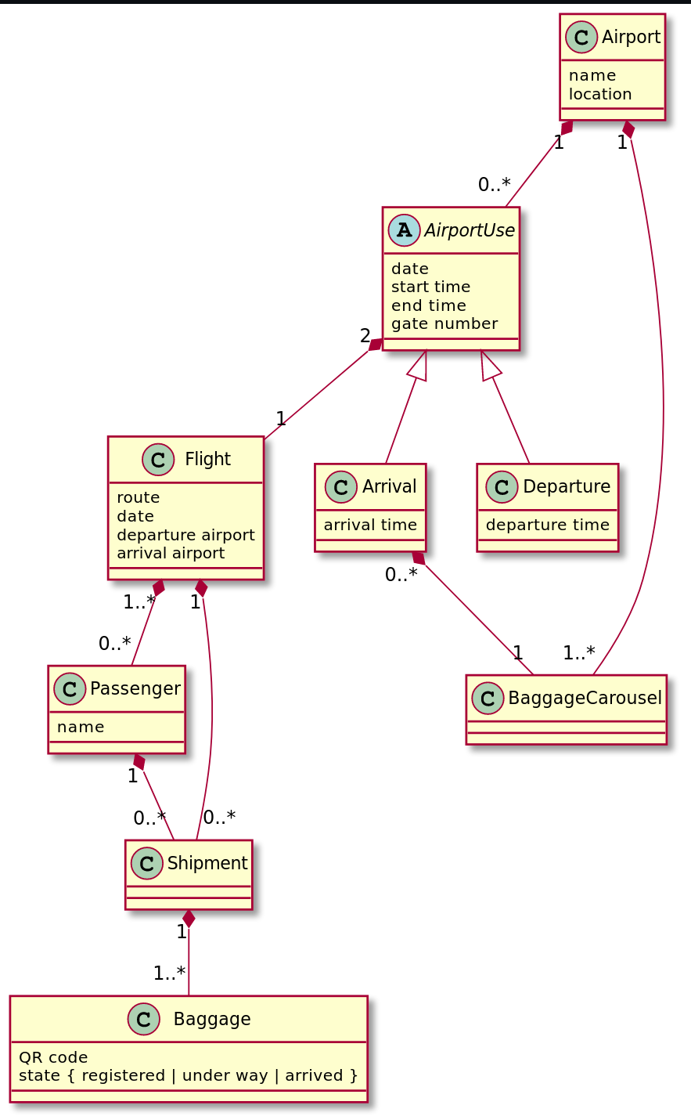

## Assignment 3. Administration of a Ski Resort (40%)

This assignment is about a system for administration of ski resorts and the use of services provided by the resorts. The services are rental of accommodation (hotel rooms and cabins), rental of ski equipment (skis, boots, poles and helmets), buying of lift cards for ski lifts and consumption in restaurants in the resort.

The system developers have made the following system definition:

|  |  |
| --- | --- |
| F | Customers use the system to register their name and address. They also use the system to rent accommodation before they arrive at the resort. After having registered, they can access information in the system about their use of services. Customers rent accommodation through the system as well as ski equipment. The lift card is used to get access to the ski lifts in the resort. Customers can get a detailed list of all expenses they have incurred during their stay. |
| A | An IT system for administration in ski resorts of the customers and their use of the services provided by the resort. The system will be used by administrative and operative personnel employed by the ski resort as well as customers of the resort. |
| C | The system will be developed by an external software company in collaboration with the administrative personnel and a couple of selected customers. |
| T | The system will run on the customers’ smartphones, and the personnel’s PCs and smart-phones. There will be a server in the administration centre that the personnel’s and customers smartphones acquire information from. Sensors in the ski areas are used to determine the positions where each customer has been and this is recorded on the server. |
| O | A resort has a number of accommodations (hotel rooms and cabins) that it rents to its customers. The customers can also rent ski equipment, and they can buy food and drinks at the restaurants in the resort. Each customer will have a lift card. There is a number of positions, where each is part of a ski slope, and they can be either a lift for the slope or a location on a slope. |
| R | The aim of the system is to ensure accurate billing of all expenses of customers and to provide them with information about their skiing activity. |

The administration of the ski resort has the following characteristics:

* There are several ski resorts that use the system. A ski resort is created when it starts using the system. If it stops using the system, it becomes passive.
* A customer is created the first time he/she visits one of the resorts in the system. The customer’s record in the system will continue to exist for every year the customer visits a resort that is using the system.
* Each resort has a number of restaurants, accommodations (hotels and cabins), ski equipment and positions in the ski area. For each of these, new objects can be added when they are acquired, and be deleted when they are no longer used.
* The accommodation expense is added to the customer’s bill upon arrival at the resort.
* During the stay, customers register their consumption of food and drinks in the restaurants of the resort. Customers also register their ski equipment rentals and the lift cards they buy.
* Customers pay their bill when the stay is over.

Below is a class diagram of the problem domain:

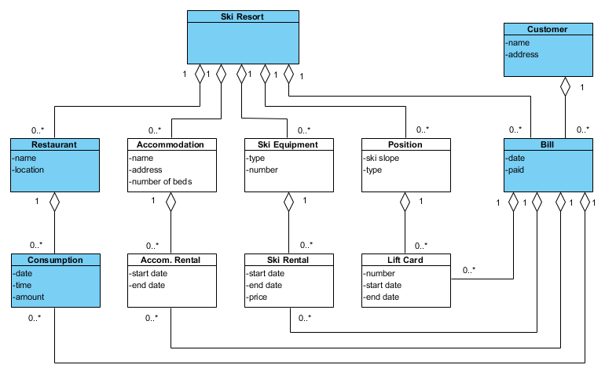

### Assignment 3.1. Object-Oriented Patterns (5%)

Identify object-oriented patterns for structure between the following five classes in the class diagram above (the blue classes): Ski Resort, Restaurant, Consumption, Customer, and Bill. For each pattern describe which classes it connects and if relevant, the role of each class in the pattern.

*Write your answer in the table below (there are more rows than needed):*

|  |  |
| --- | --- |
| **Pattern** | **Classes connected** |
| Hierarchy | Ski Resort, Restaurant, Consumption |
| Hierarchy | Ski Resort, Bill, Consumption |
| Hierarchy | Customer, Bill, Consumption |
| Item-descriptor | Restaurant, Consumption |
| Role | Ski Resort, Restaurant, Bill (OOA&D page 83) |
|  |  |
|  |  |
|  |  |
|  |  |
|  |  |

### Assignment 3.2. Statechart Diagrams (20%)

The behaviours of objects from the five blue classes in the class diagram of the problem domain have the following characteristics in addition to what is described above:

* Each time a customer visits a restaurant, a new consumption is created, and all food and drinks consumed at that time are recorded with that consumption. When the customer leaves the restaurant, the consumption is completed and added to his/her bill.
* When the customer leaves the resort, the bill is closed.
* The closed bill is sent to the customer for payment.
* If the bill is not paid, it is sent to the customer again as a reminder.
* If the bill is still not paid after a number of reminders, it is sent to debt collection. The number of reminders sent before sending the bill to debt collection is decided by the individual resort, and it may thus differ between resorts.

Make statechart diagrams for the following five classes (the blue classes in the class diagram): Ski Resort, Restaurant, Consumption, Customer, and Bill. Write the diagrams below in that order. You can ignore event attributes.

*Insert your solution here and on the next page:*

(black bars are just used for iteration to the same state, seeing as PlantUML does not handle multple self iterations well)

Ski Resort

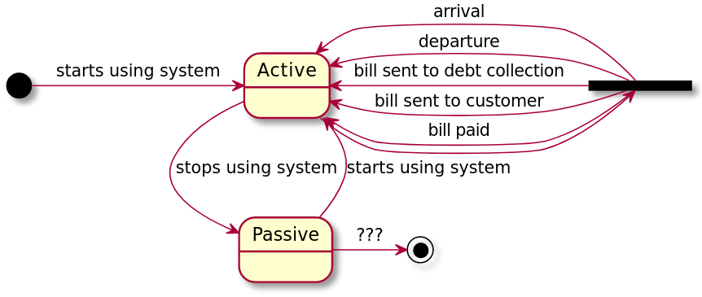

Restaurant

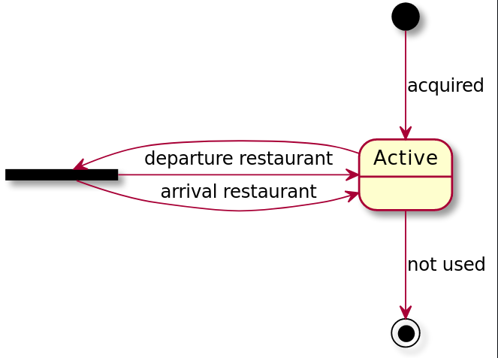

Consumption

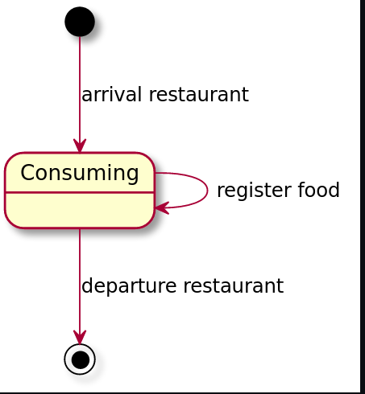

Customers

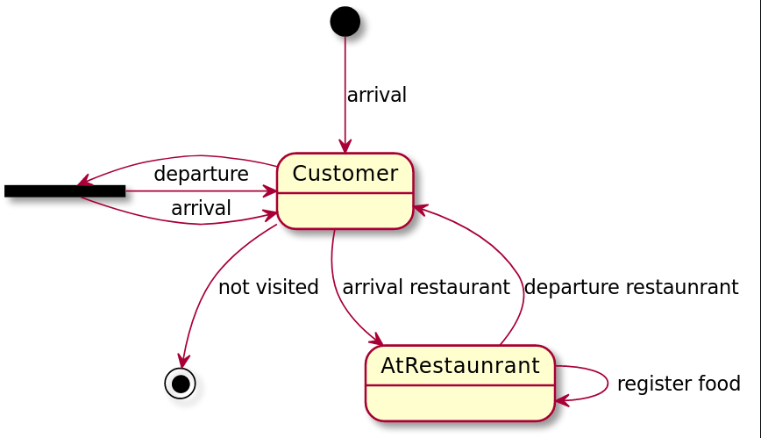

Bill

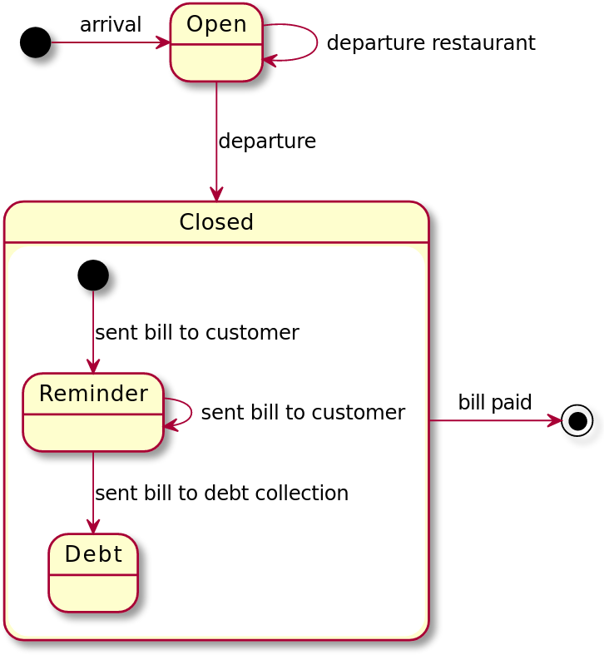

### Assignment 3.3. Event table (5%)

Make an event table (with ‘+’ for sequence and selection; and ‘*’ for iteration) for the model of the part of the problem domain that is covered by the five statechart diagrams above.

*Insert your solution here:*

|  |  |  |  |  |  |
| --- | --- | --- | --- | --- | --- |
|  | Ski Resort | Restaurant | Consumption | Customer | Bill |
| Starts using system | * |  |  |  |  |
| Stops using system | * |  |  |  |  |
| Not visited |  |  |  | + |  |
| Acquired |  | + |  |  |  |
| Not used |  | + |  |  |  |
| Arrival | * |  |  | * | + |
| Departure | * |  |  | * | + |
| Register Food |  |  | * | * |  |
| Arrival restaurant |  | * | + | * |  |
| Departure restaurant |  | * | + | * | * |
| Bill sent to customer | * |  |  |  | * |
| Bill sent to debt collection | * |  |  |  | + |
| Bill paid | * |  |  | * | + |

### Assignment 3.4. System Architecture (10%)

Describe the overall architecture of the system and the reasons for choosing that. After that, make a diagram of a system architecture for the system with the sub-systems on the server and the personnel’s smartphones.

*Insert your solution here:*

Seeing as there is a central server and people as well as personal will access the system using smartphones and computers the Client Server architecture should be our choice. We will add another component though, the sensor.

The distributed data model should be used, so that clients have access to the relevant parts of the model. This way clients should be able to see all of their expenses, register food and other expenses and send updates to the server when they regain internet access.

The server will have the whole model + functions + user interface, such that there is a single place where everything comes together. Thus all new model data is sent to the server and all needed model data is retrieved from the server.

The sensor holds its own simple model which is just positional data from the customers that it registers. Where it sends new data to the server when possible. I will assume that the sensor can differentiate visitors without needing to communicate with the client component.

All three components will be based on the generic architecture because the requirements for all of these can change over time, so having standard compononents that are closed-strict is a solid choice.

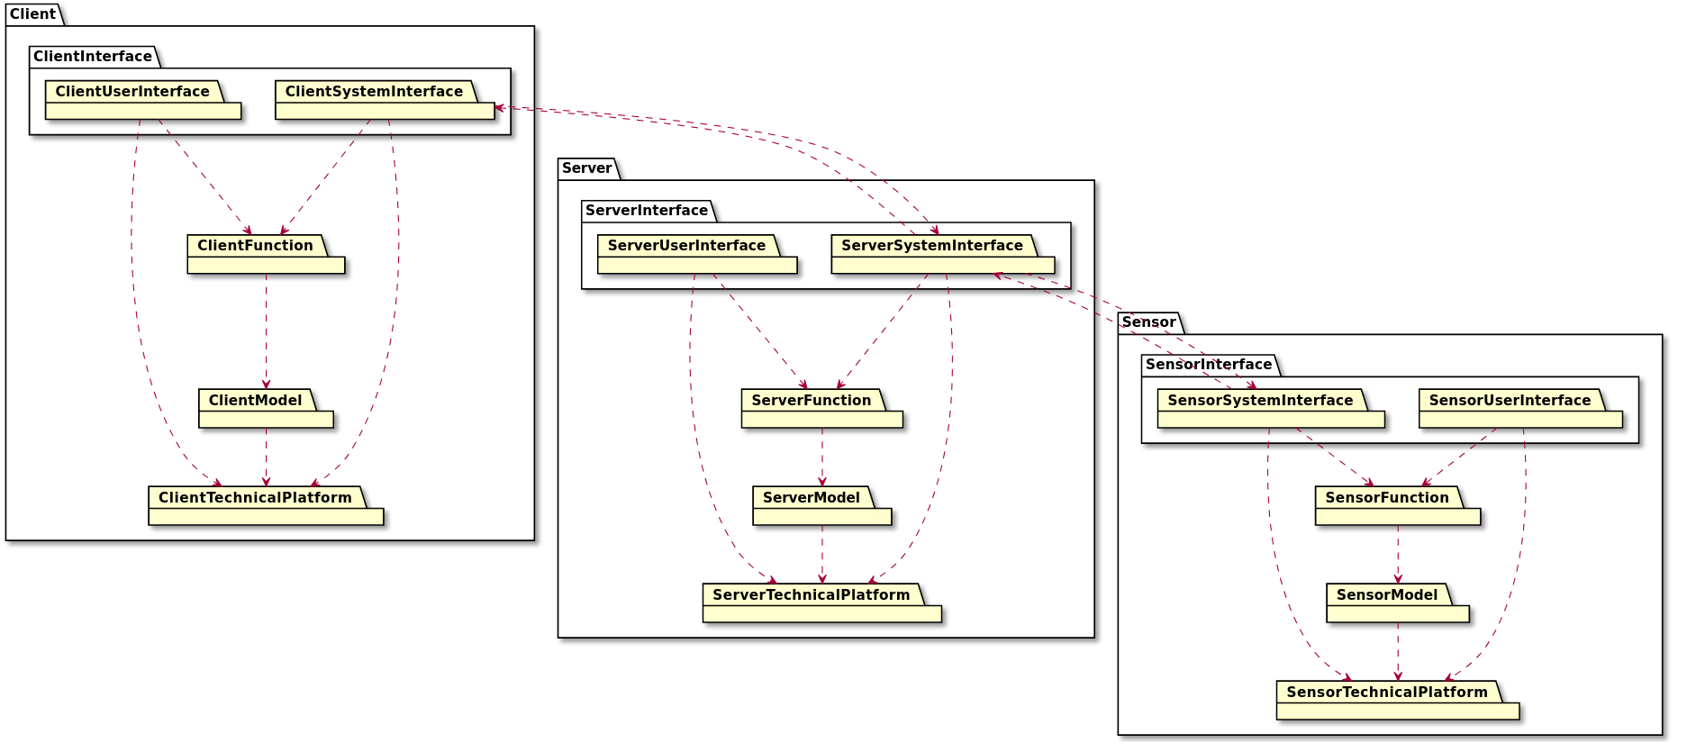

## Assignment 4. Parcel Service Administration (25%)

This assignment is about object-oriented analysis of a system for administration of the company Aalborg Parcel Service (APS) that ships products to shoppers on behalf of online retail shops. The system developers have produced the following system definition:

|  |  |
| --- | --- |
| F | Retail shops use the system to register themselves as users of APS’ services, register their shoppers as receivers of shipments, book shipments, be notified about pick up times and provide their shoppers with tracking information on their shipments. Shoppers can access tracking information about the shipment of products they have bought from that retail shop. Staff in the retail shops can follow the delivery of shipments to their shoppers. The administrative staff in APS’ headquarter can use the system to compile overall information about shipments, exploitation of shipment centres and delivery vehicles, and delivery times. The operative staff in APS will use the system to record the time and date when they pick up shipments at retail shops, pass on shipments to the next position and deliver them to shoppers. |
| A | An IT system for administration of a parcel service, its customers (retail shops) and shipping of products ordered from the retail shops. APS has administrative staff in its headquarter and operative staff in its shipment centres and delivery vehicles. |
| C | The system will be developed by an external software company in collaboration with APS’ staff and a couple of selected retail shops and shoppers. |
| T | The system will run on PCs in APS’ headquarter and on the drivers’ and customers’ smartphones. The operative staff of APS will use QR code readers on their smartphones to register shipment status and position. There will be a server in APS’ headquarter that the administrative staff’s PCs and the operative staff’s, retail shops’ and customers’ smartphones exchange information with. |
| O | A shipment is for a shopper and includes one or more products from a retail shop. A shipment is picked up at the retail shop and shipped to the shopper through a number of positions. A position is either the retail shop, a shipment centre, a delivery vehicle, the shopper’s home or a delivery centre where the shopper can pick up a shipment. |
| R | The aim of the system is to provide APS with overview of the delivery of shipments, support prompt and smooth delivery of shipments and offer retail shops and shoppers relevant information on the status of their shipments. |

The system developers have also modelled classes and objects in the problem domain with the following class diagram:

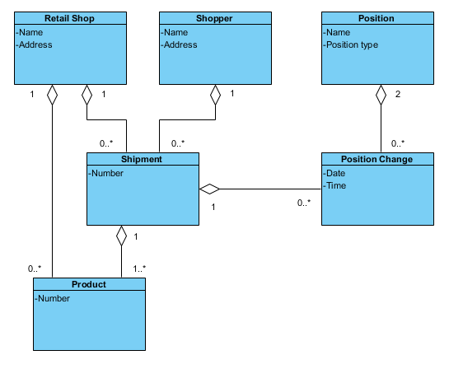

### Assignment 4.1. Actor Specifications (10%)

The system supports a number of use cases, including the following (not a complete list):

1. Register a retail shop as user of the system
2. Register a shopper of a retail shop as receiver of shipments
3. Book a shipment from a retail shop to a shopper
4. Receive notification about pick up time for a shipment at a retail shop
5. Record the time and date when a shipment is picked up at a retail shop
6. Record that a shipment is passed on to the next position or delivered to a shopper

Make the actor specifications that are relevant for the use cases above.

*Write your solution here:*

**Retail Shop**

**Goal: The goal of the retail shop is to book new shipments for customer and register new customers if needed.**

**Characteristics: Characteristics can vary greatly from retail shop to retail shop, common for all though is that the IT-skills of the workers is very varying.**

**Examples: Retail Shop A has a bunch of workers that have a high level of IT skills, thus that shop almost always has someone in the shop that can register a new customer without any issues.**

**Retail Shop B, does not have many workers that are comfortable using computers, this means that at most times the shop does not have anyone that feels comfortable using a system, though they do use the system quite a bit and after using the some for some time most workers seem comfortable with the system.**

**Operative Staff**

**Goal: The goal of the operative staff is to get shipments from point A to point B and make sure to register this by scanning the QR codes on the shipments.**

**Characteristics: Workers in the operative staff can have varying degrees of it skill, however they will use the system a lot, thus everybody will a lot of experience and get better at using the system very quickly.**

**Examples: Operative A is very happy using the system and they started exploring the different features of the system the first chance they had.**

**Operative B is not very comfortable with the system the first couple of days, however after a little hardship B feels very comfortable using the system.**

**Shopper**

**Goal: The goal of the shopper is to see when and where they can pick their shipment, as well as where it is currently.**

**Characteristics: This will vary greatly as almost everyone uses a retail shop, thus it skill will vary greatly.**

**Examples: Shopper A has used systems like these many times before and uses it quite fluently.**

**Shopper B has never used a system like this before, and finds to be a little intimidating at first.**

### Assignment 4.2. Actor Table (7%)

Make an actor table with the relevant actors and the use cases above.

*Write your solution here:*

|  |  |  |  |
| --- | --- | --- | --- |
|  | Retail Shop | Operative staff | Shopper |
| Register a retail shop as user of the system | x |  |  |
| Register a shooper of a retail shop as a receiver of shipments | x |  |  |
| Book a shipment from a retail shop to a shopper | x |  |  |
| Receive notification about a pick up time for a shipment at a retail shop | x |  |  |
| Record the time and date when a shipment is picked up at a retail shop |  | x |  |
| Record that a shipment is passed on to the next position or delivered to a shopper |  | x |  |

### Assignment 4.3. Use Case (8%)

Make a use case specification (by a statechart diagram) for ‘Book a shipment from a retail shop to a shopper’ (with objects and functions). If necessary, you may introduce new attributes to the classes in the problem domain; if you do so, make a note about it at the bottom of your solution.

*Insert your solution here:*

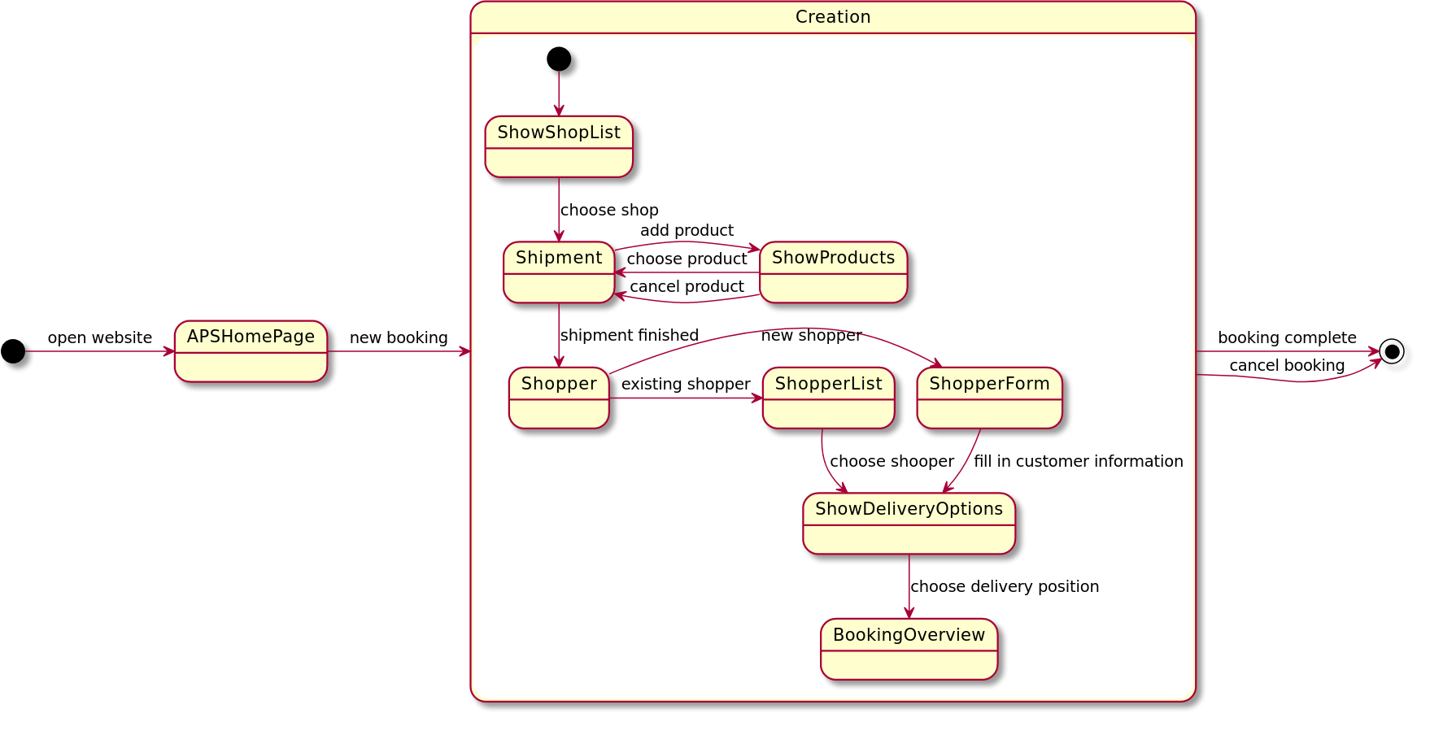Objects: Retail Shop, Shopper, Position (from ShowDeliveryOptions), Shipment, Product

Functions: ShowShopList, ShowProducts, ShopperList, ShowDeliveryOptions, CreateShipment, AddProductToShipment, CreateShopper